**Agents:**

**Agent Purpose is to perform backgroud processing/ Bulk Processing batch wise at some scheduled time intervals**

**Sysadmin-> Agents**

**- Under 1 Instance we can add Multiple Agents.**

**- Agent is associated with name, Schedule Time, ClassName name, Activity & Access Group**

**- PRPC contains a Master Agent ( System Pulse). This will monitor all the user defined agents.**

**- Agent is an instance of Rule-Agent-Queue**

**Working with Advanced Agents:**

**Req:  Create an Advanced Agents Rule to send email notification for every 30 sec.**

**Create an Activity: Create Under Work Layer**

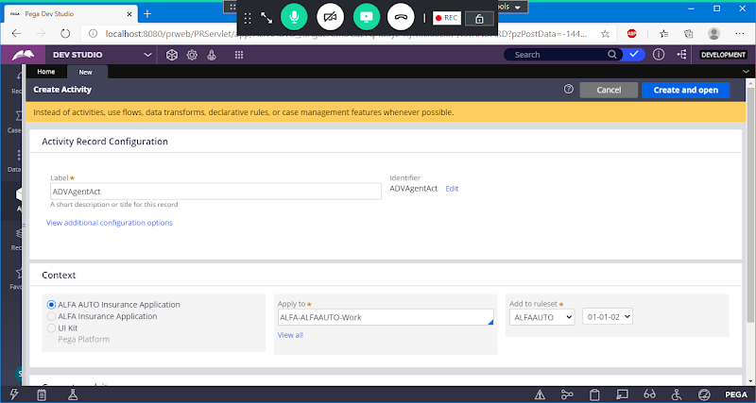

**Open**

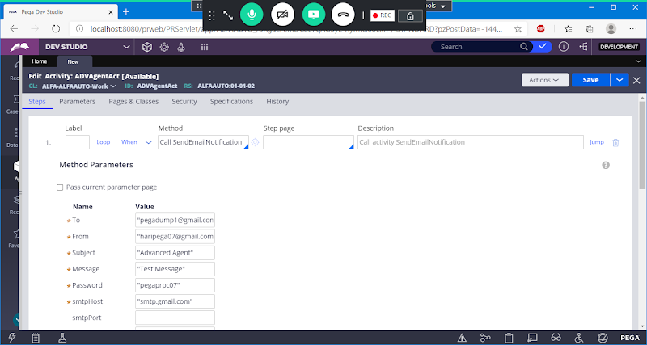

**Enable : Use SSL**

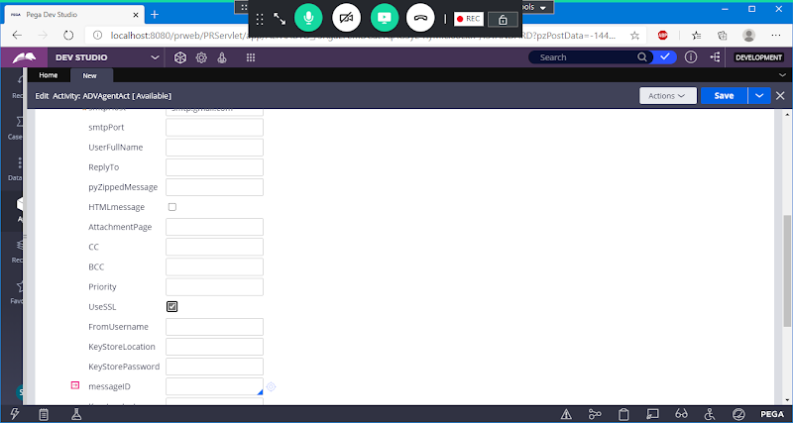

**Go to Security tab:**

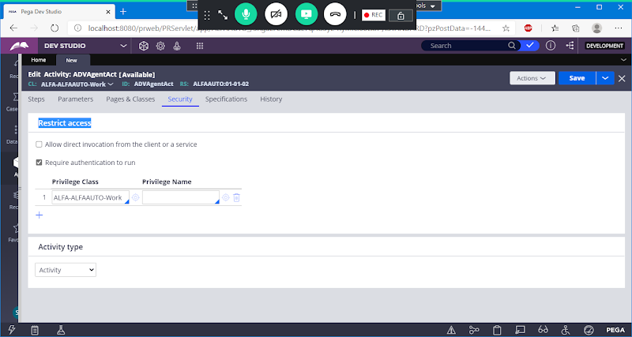

**Uncheck Requires Authentication**

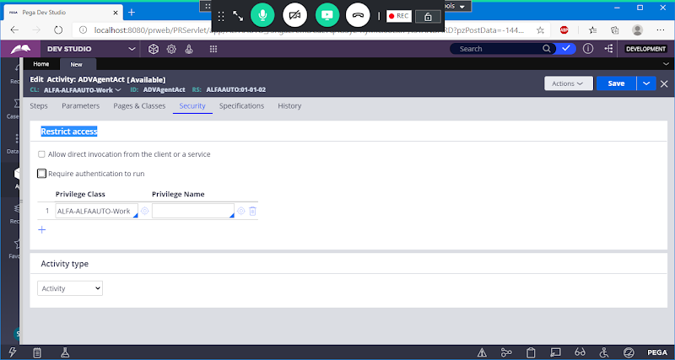

**Enable: Allow direct invocation from the client or a service**

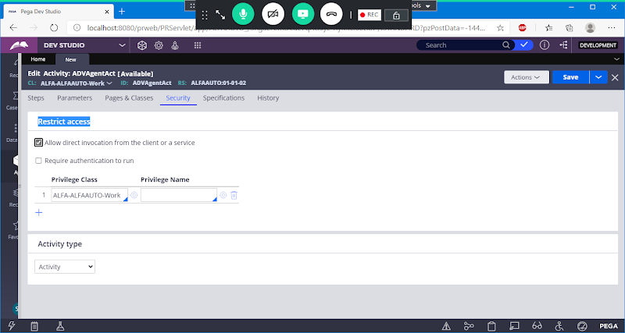

**Save Activity**

**Create Agents Rule:**

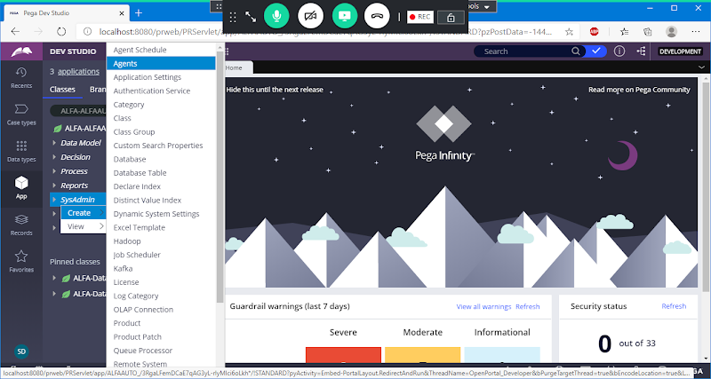

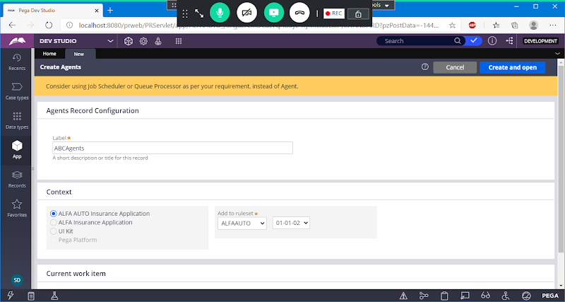

**Open**

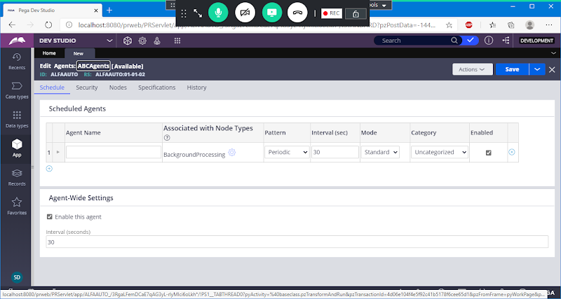

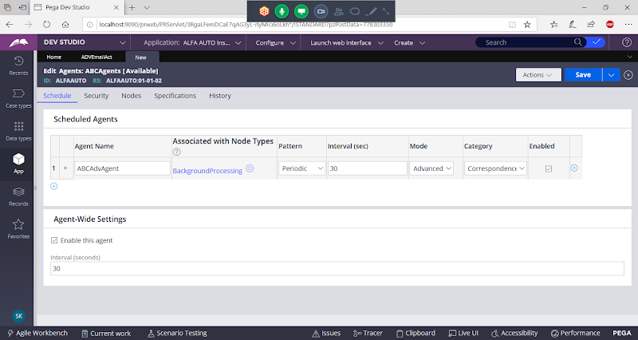

**Select Pattern: Periodic ( 30)**

**Select Mode: Advanced**

**Select Category: Correspondence**

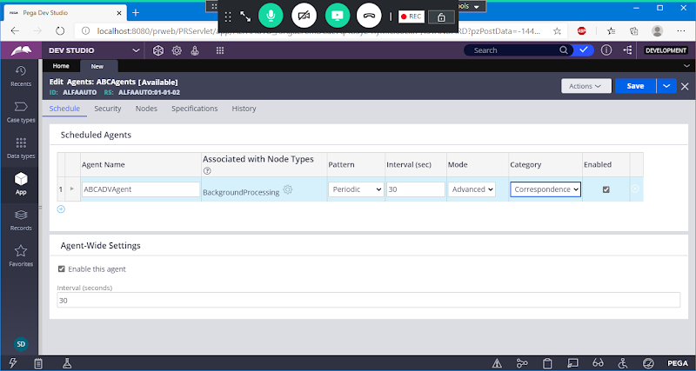

**Expand**

**Add Class Name & Activity Name**

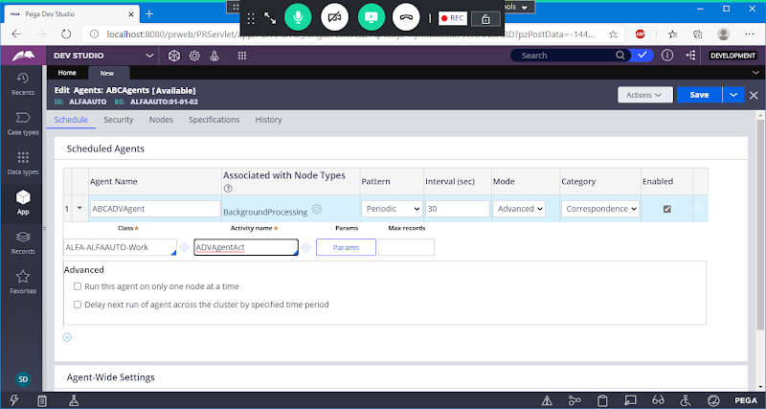

**Select Check Box Under Advanced settings:**

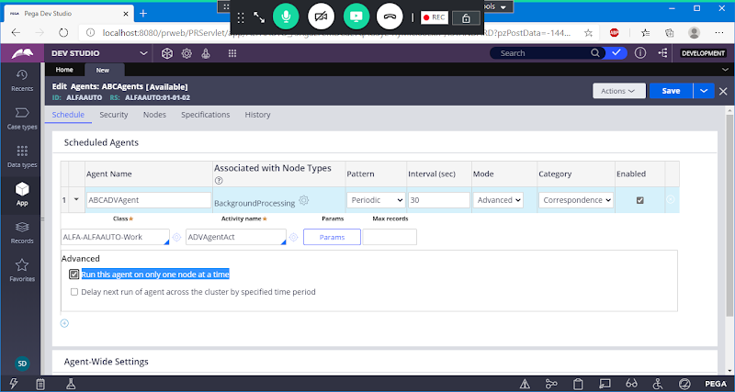

**Go to security Tab:**

**Add Access Group Name:**

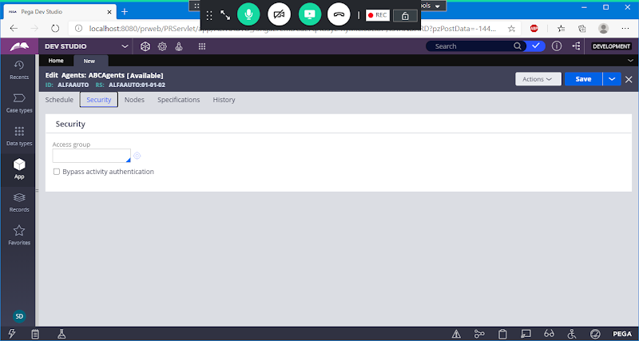

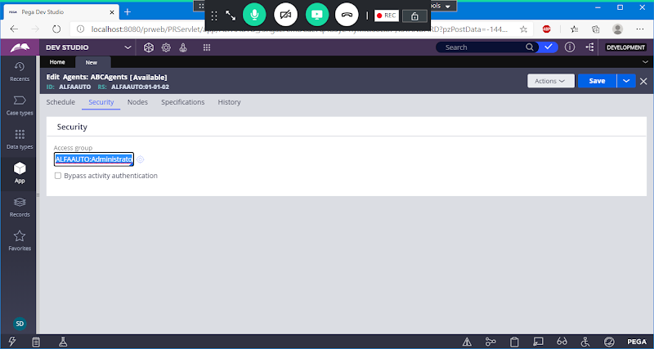

**Save Agents**

**Go to Nodes Tab:**

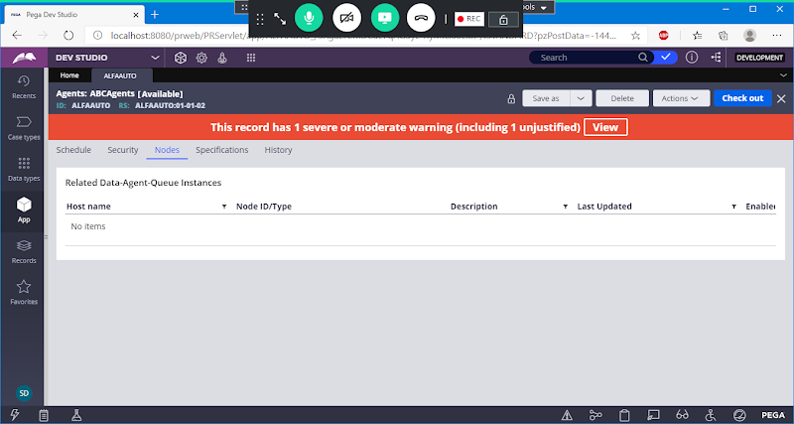

**After Saving Agent.**

**- After Agents gets Created, it will take sometime to sync on the Node. It will take 5 min or more to sync on the server.**

**-If Node is not synced, Restart PEGA Server ( i.e Shut down & Start server again)**

**How to Manage Agents: ( Start / Stop/ Restart/Trace)**

1. **AgentsSchedule ( Start/Stop)**
2. **Admin Studio->Resources - Agents**

**sysadmin rules in Application open from Records Explorer:**

**Open your Agents from Records Explorer-> Sysadmin-> Agents**

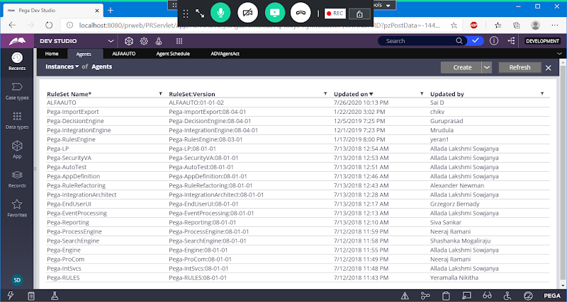

**Open Agents & Go to Nodes Tab and check Node ID is generated or not**

**GO to Nodes Tab:**

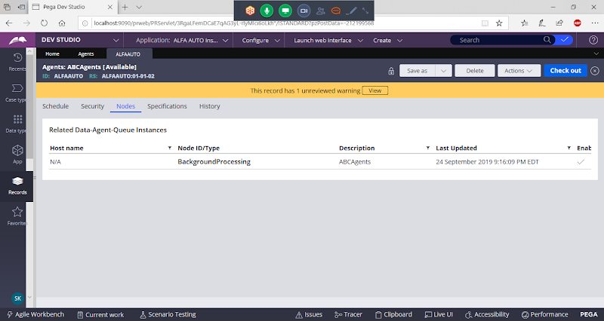

**After Node is Created.**

**Now check your email. You will receive notification for every 30 seconds.**

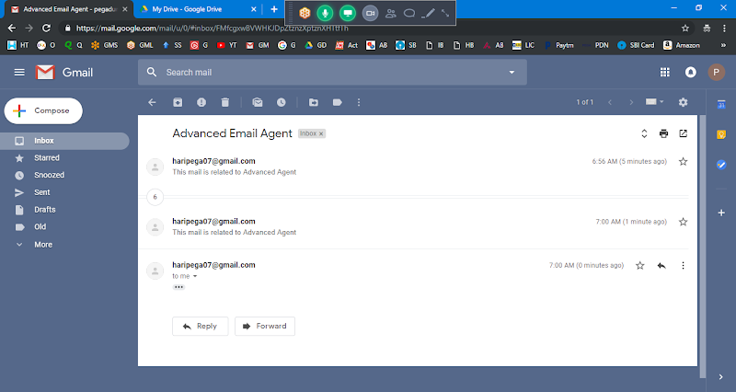

**To stop receiving the notification stop the agent using Agent Schedule**

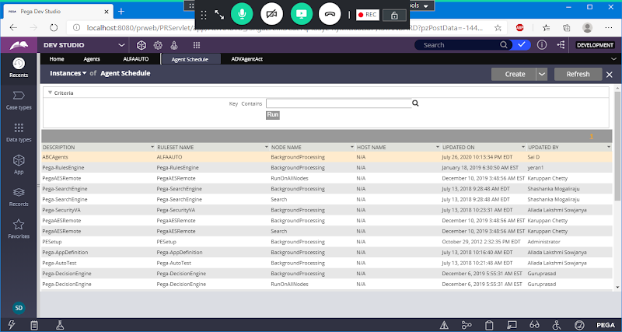

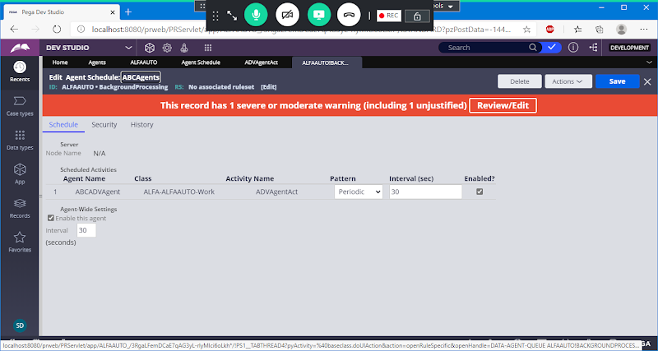

**How to Stop Agent:**

**To Stop Agent Uncheck ur agent from Agent Schedule.**



**Disable Check Box**

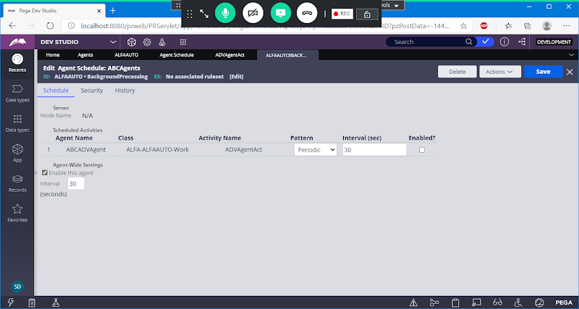

**Save Agent Schedule**

**We can also use Admin Studio to Manage Agents:**

**Open Admin Studio:**

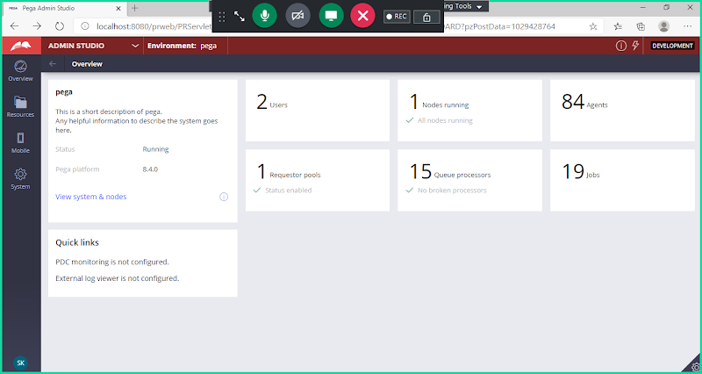

**Go to Resources -> Select Agents**

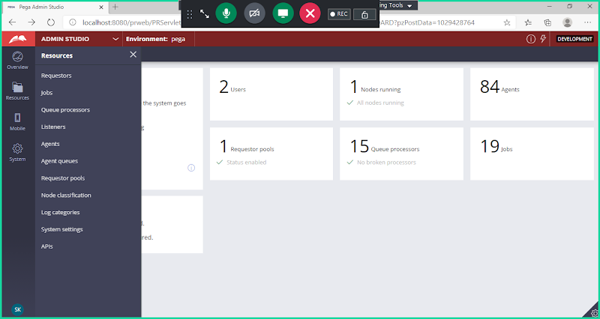

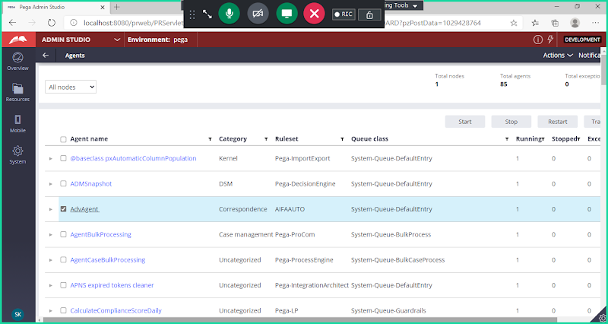

**Select Checkbox -> we can start/Restart/stop/trace our agents**